GroundCrew. AI Stage 4

- In Copilot Studio, Go to “topics” on the navigation bar

- Let us allow the agent to orchestrate the conversation from the get-go now. Start by clicking “System” in topics and select “conversation start”.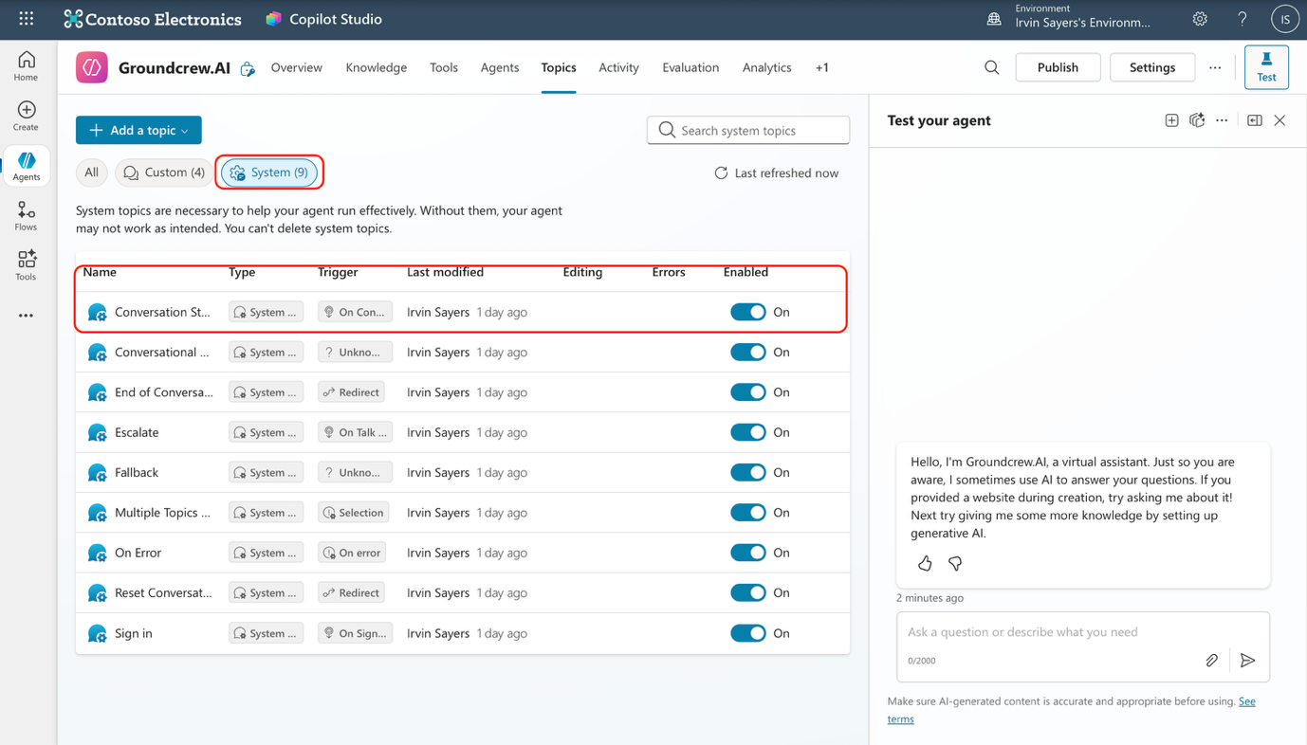

- Delete the “Message” node and add a “ask a question node”

- In the “Message” section, type out any welcome message you would like or just copy and paste this message.
“Hey! I am Groundcrew.AI, your personal pre-onboarding assistant, I can help you upload your headshots, verify your Email address and answer any pre-onboarding related questions”
Let me know what you would like to do.
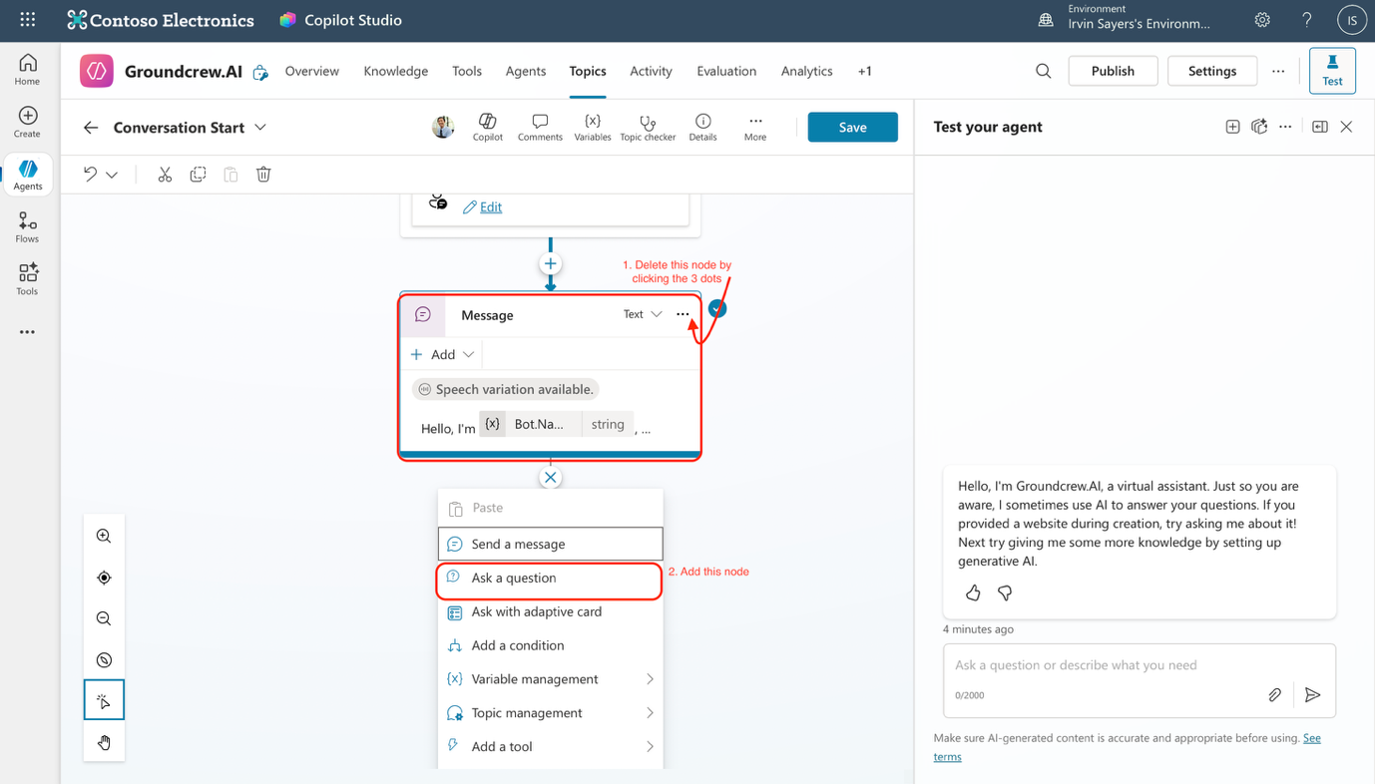

- Click “+ New option” under options for users and add 3 options
- Upload headshot
- Verify Email ID
- General Enquiry

- Copilot studio would have added 4 “Condition” automatically for you, as seen below. Let us configure just the “general enquiry” one and leave the rest blank for now.
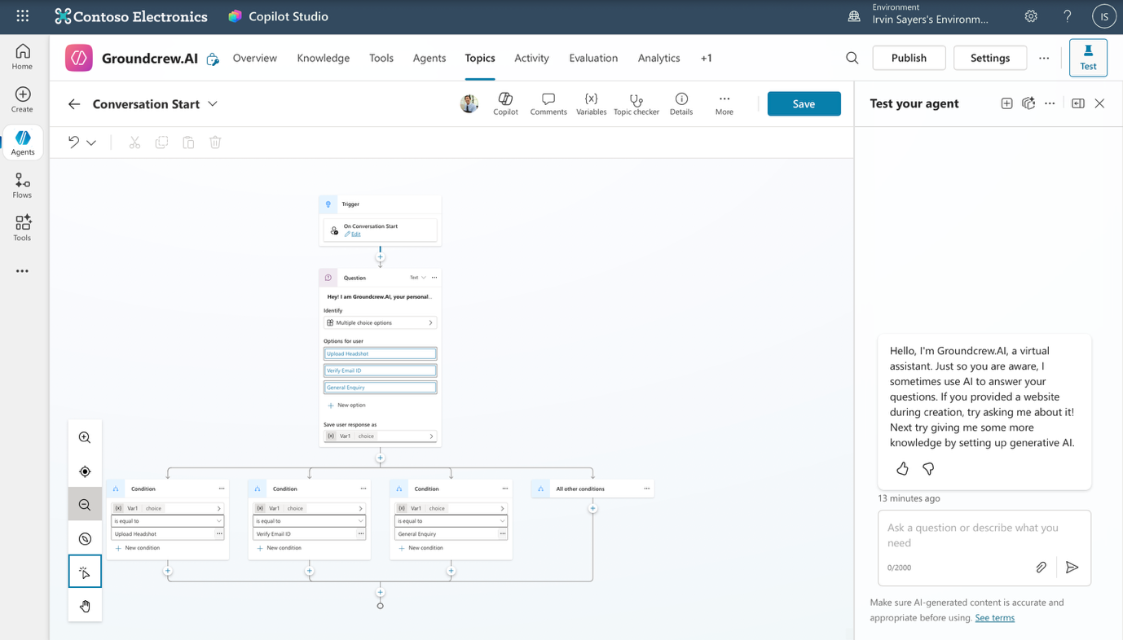

- Click the “+” sign below the “var1 is equal to General Enquiry” node and choose “Topic management” then “Go to another topic” then choose “conversational boosting”
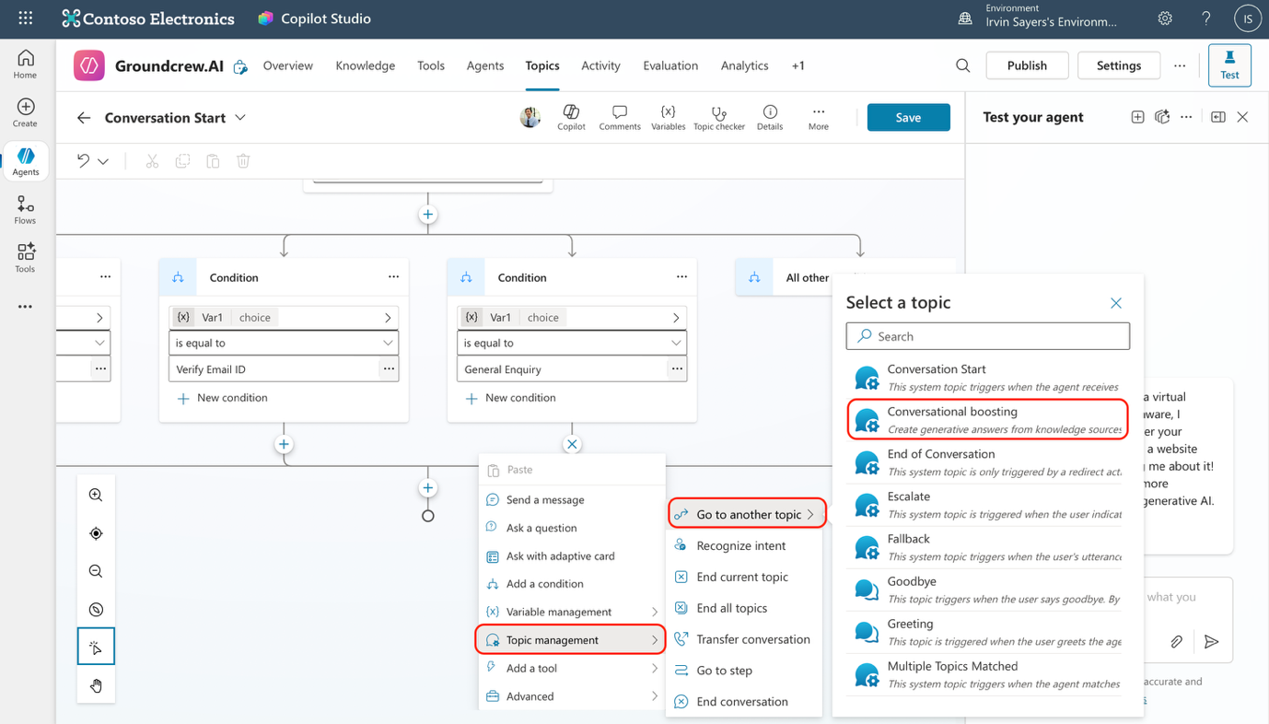
This allows the agent use the “conversational boosting’ capability to use the generative AI capabilities and answer questions form users if they choose general enquiries.

- Congratulations! You have finished configuring your first topic. You can test your agents “General enquiry” capabilities. Next we will move to creating the topic and introduce creating “Flows” to upload your headshots!

